***Big ben tower clock model***

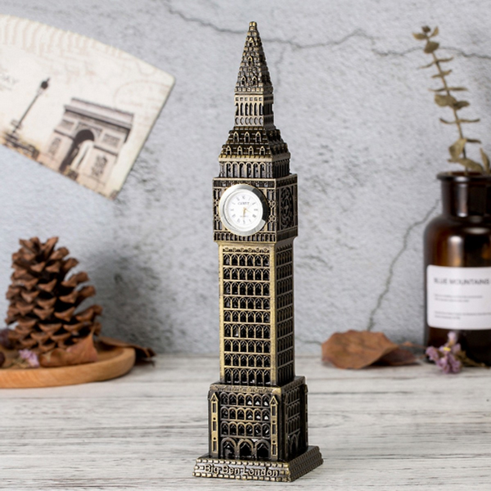

*The Big ben tower clock has a core made of glass, and the outside is covered with layers of powder-coated metal. Has a color changing LED light. The product is suitable as a birthday gift for boyfriend, girlfriend, housewarming gift, ...*